(Approx. 321 words)

Windows 8/8.1 Corner
Advanced Functions – Power Menu
By Rosita Herrick, Yahoo Forum Moderator, Sarasota Technology User Group, FL
http://thestug.org/
Rosita (at) thestug.org

This article is for users that are by now familiar with Windows 8/8.1 and are trying to use more advanced functions.

One of the options to manage your computer is the capability to right click on the start icon in the lower left corner of the screen, and display the power menu.

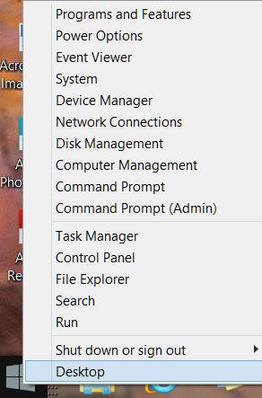

As you can see, from here you can navigate to quite a few pages that used to take 3 or more clicks (if you remembered how).

Here are details about some of the option to use to manage your system.

System

Click on this link to find out details about your system like amount of RAM, Windows edition, 32 or 64 bit based processor. Among others, you also have a link on this page to the Device Manager.

Disk Management

This link loads the configuration of all the disks accessed by your computer, how they are partitioned, capacity, etc. Here is an example:

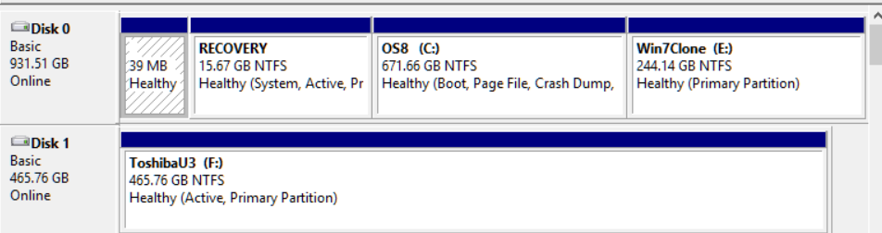

Disk 1 is a Toshiba USB 3 external hard drive.

Task Manager

You can still access the Task Manager by pressing Ctrl+Alt+Delete. But clicking on the Power Menu link is easier and it starts the Task Manager immediately. The initial display is of the programs and/or apps running. To see more details, click on the More details link. To cancel any item that possibly has stopped working and does not respond, click on the End task box.

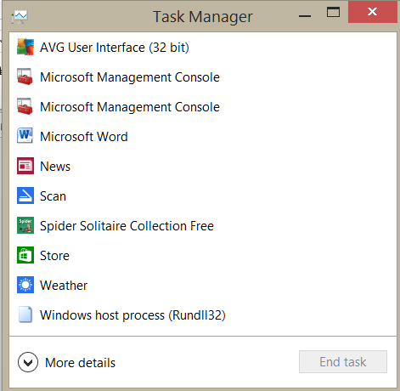

As you scan the Power menu you will see the quick option to shut down or sign out.
The Search link gets you to the Search. You also have a fast link to the following:
Control Panel
File Explorer
Device Manager, etc.

In conclusion, the Power Menu makes navigation to Windows internals faster and easier to the user.

Try it sometime, I am sure you will like it.

